The following will show you how to login to office.com to access outlook (student email) and Microsoft Teams.

Step 1: Go to office.com and click the “Sign in” button
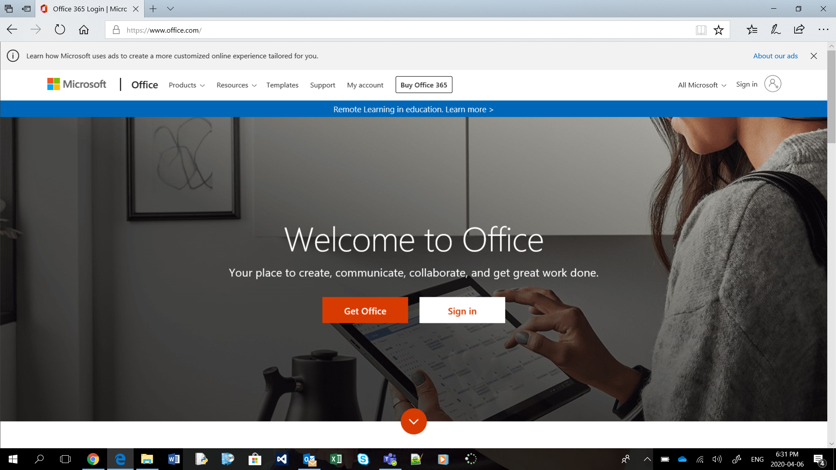
Step 2: On the sign in page enter your school email account (username@nbss.nbed.nb.ca) 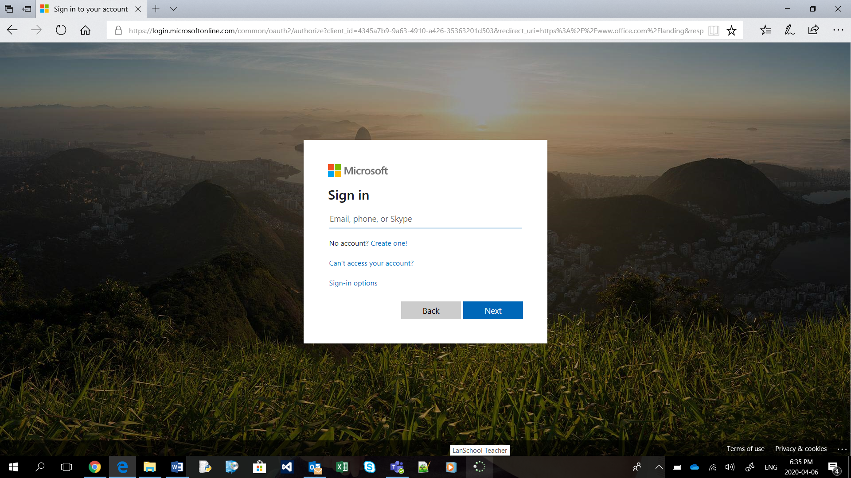

Step 3: Type in your school email address and student password (same password you would use to sign-in to a school computer or connect to the wifi with your phone)
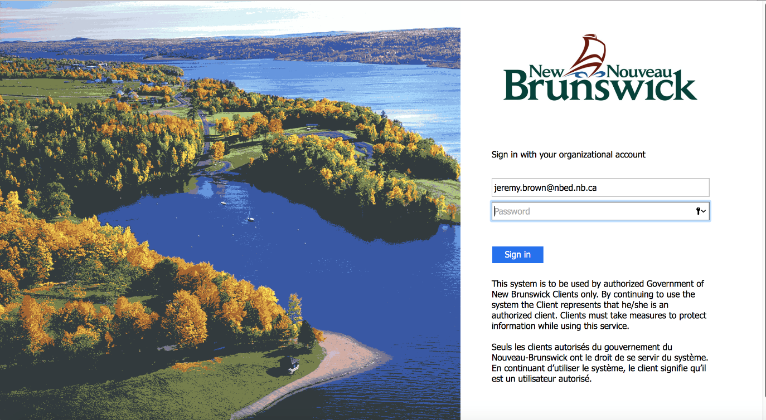
Step 4: You should see a list of apps at the top of the screen. If you don’t, click the 9 dots in the upper left corner.
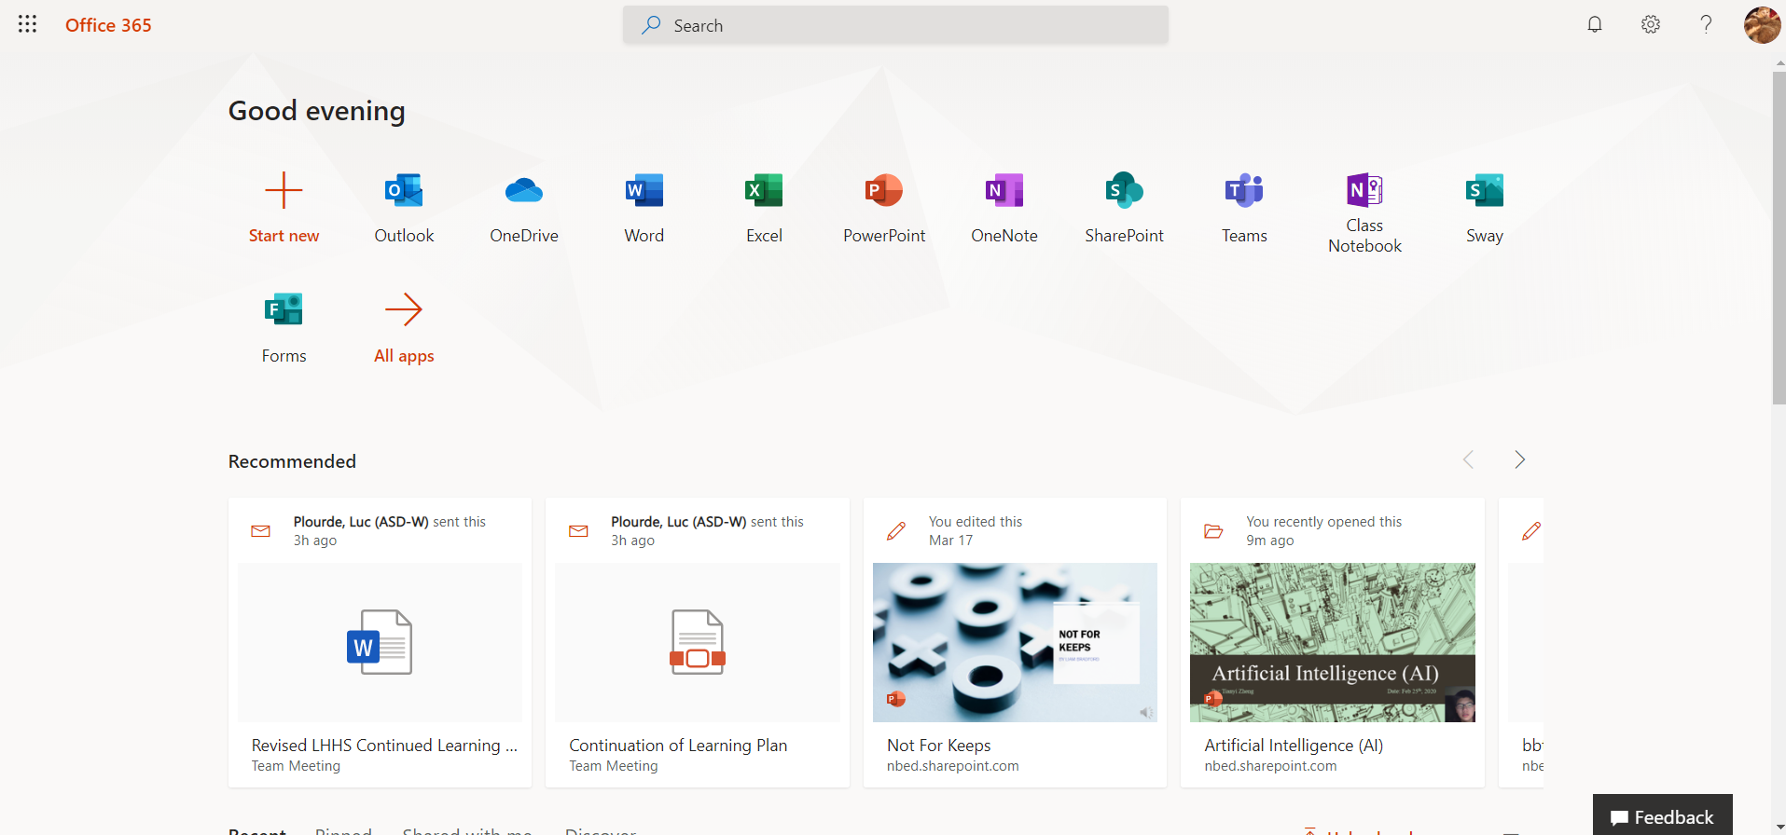
Step 5: Select the app you want to use. For Student email select Outlook. For Teams select Teams.

